SPRING 2026 | CSD440 SERVER-SIDE SCRIPTING | AUTHOR: BRITTANEY PERRY-MORGAN
MODULE 10
GitHub Repository Link: https://github.com/devcnx/csd440
Deliverables
All Fields Empty — Nine required-field errors in the error summary and inline below each field
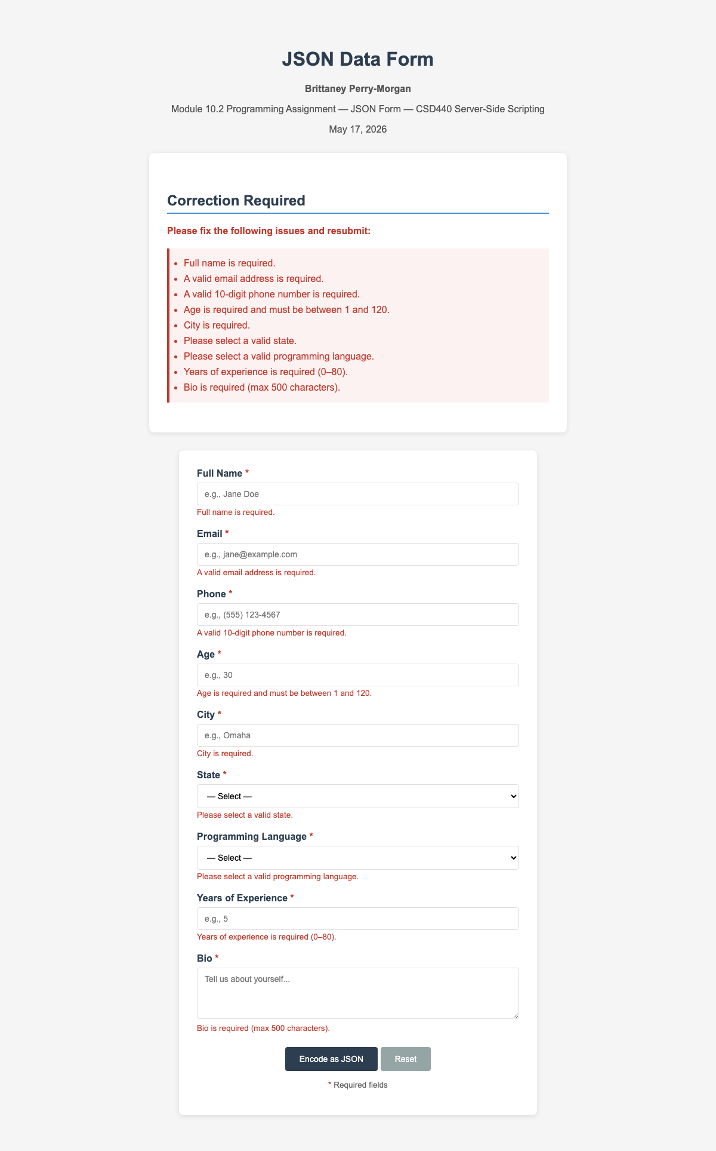

Full Name > 100 Characters — 'Full name must be 100 characters or fewer' with name field preserved
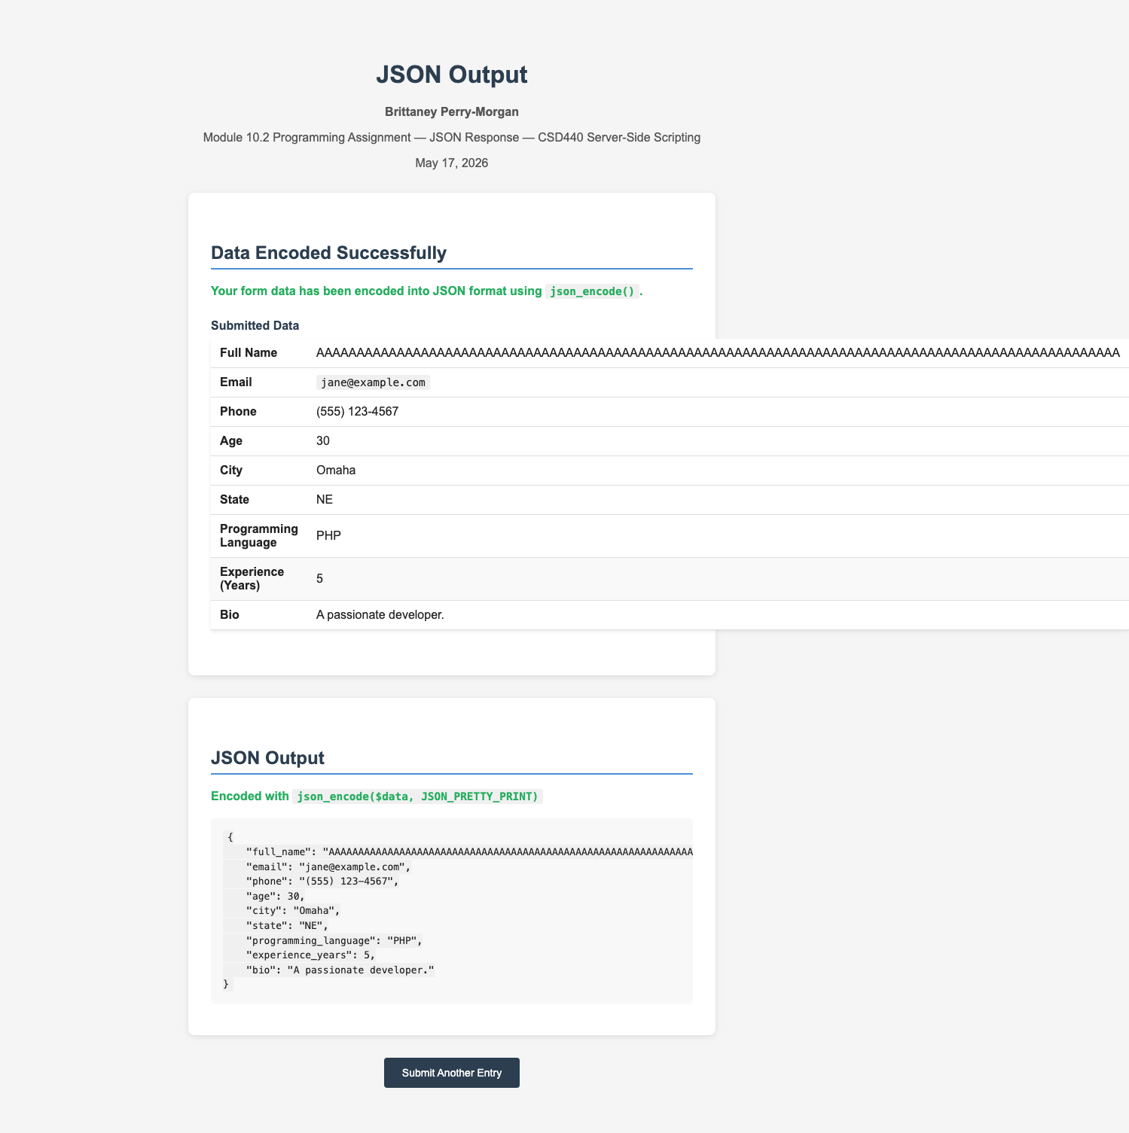

Invalid Email Format — 'A valid email address is required' with email value preserved
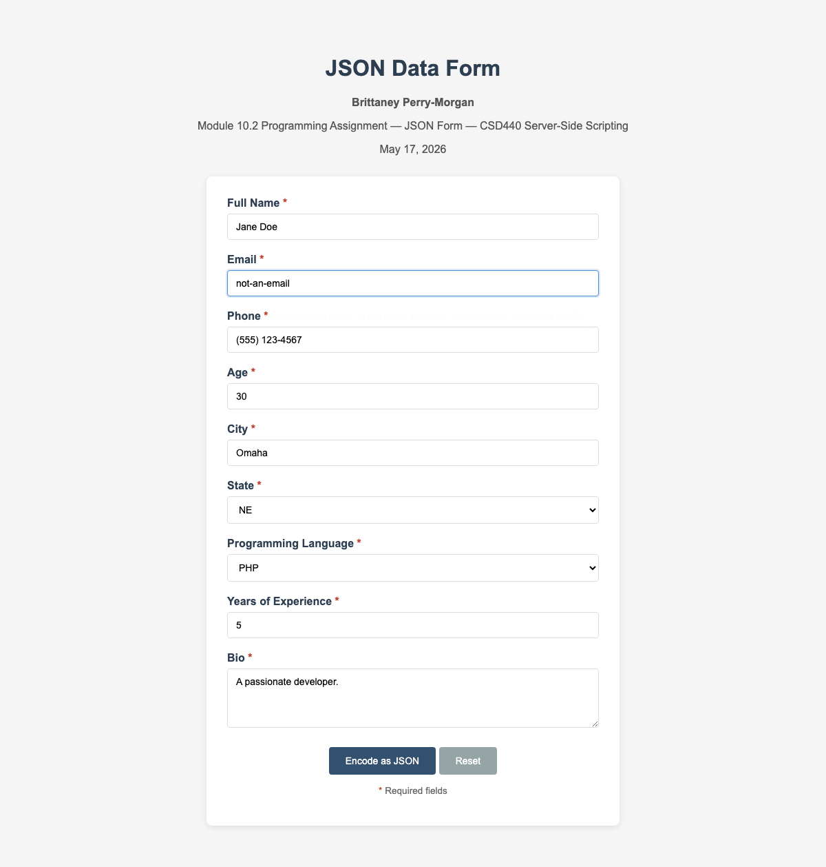

Phone Too Short (5 digits) — 'A valid 10-digit phone number is required' with value preserved
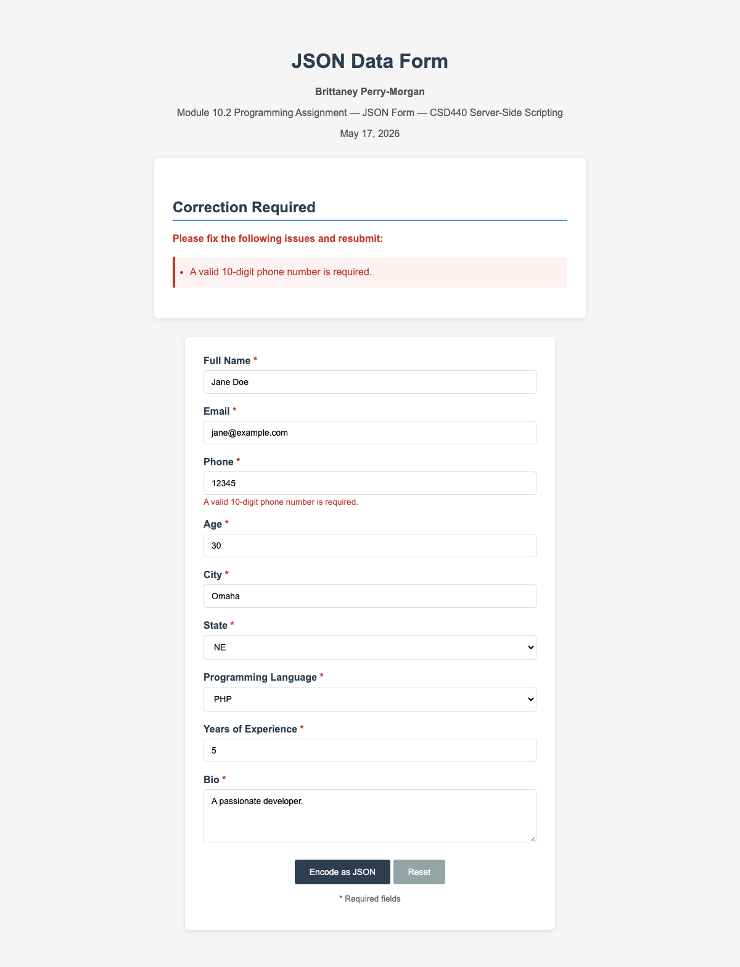

Phone Contains Letters — 'A valid 10-digit phone number is required' with value preserved
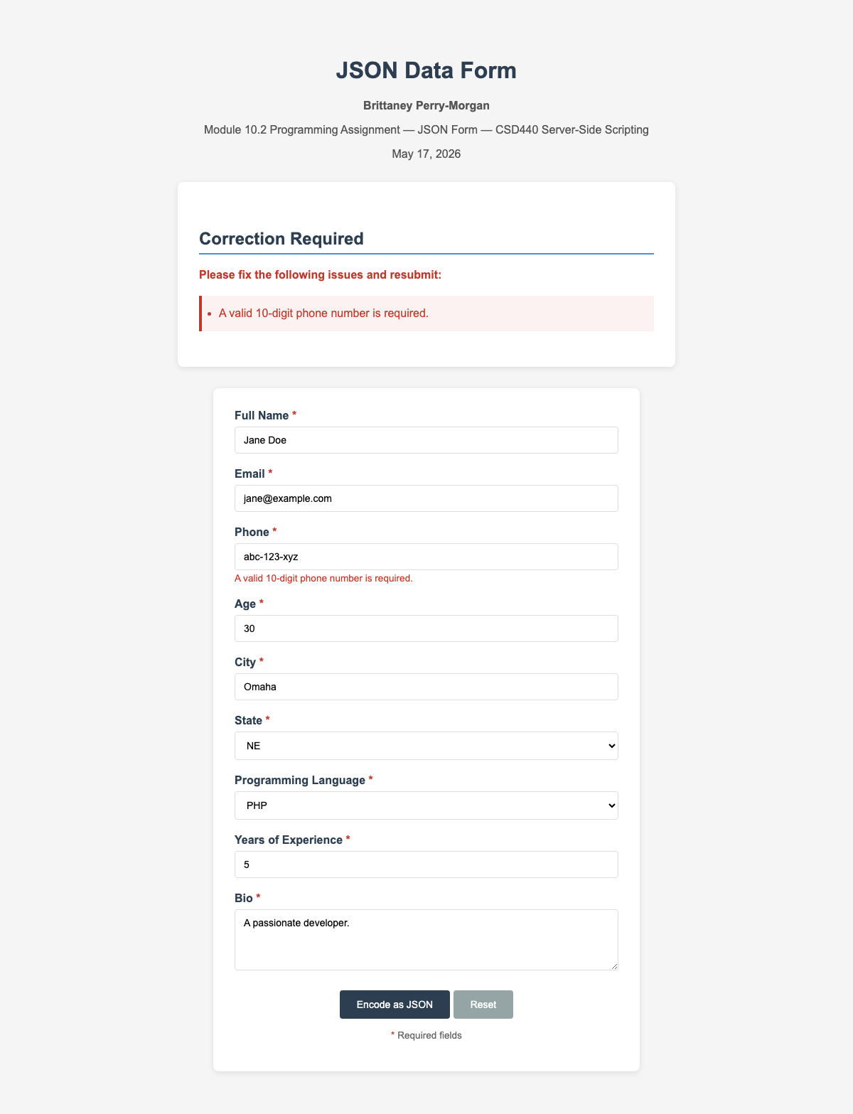

Phone Too Long (12 digits) — 'A valid 10-digit phone number is required' with value preserved
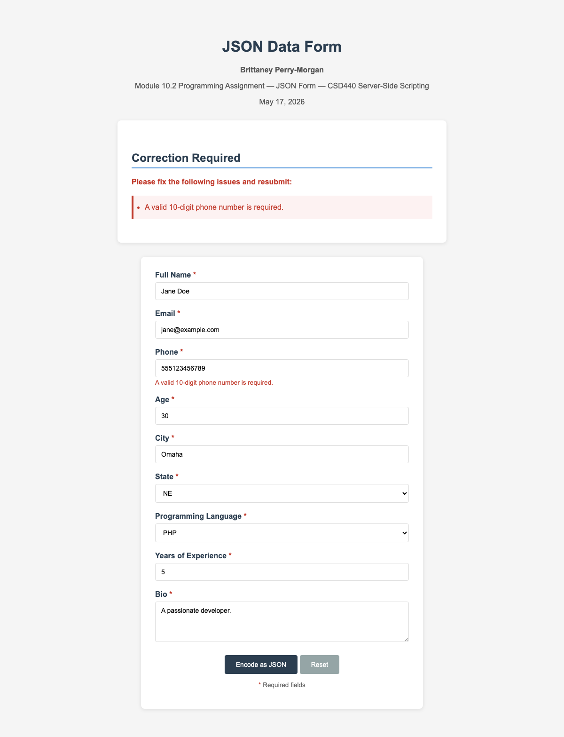

Age Below Minimum (0) — 'Age is required and must be between 1 and 120' with value preserved
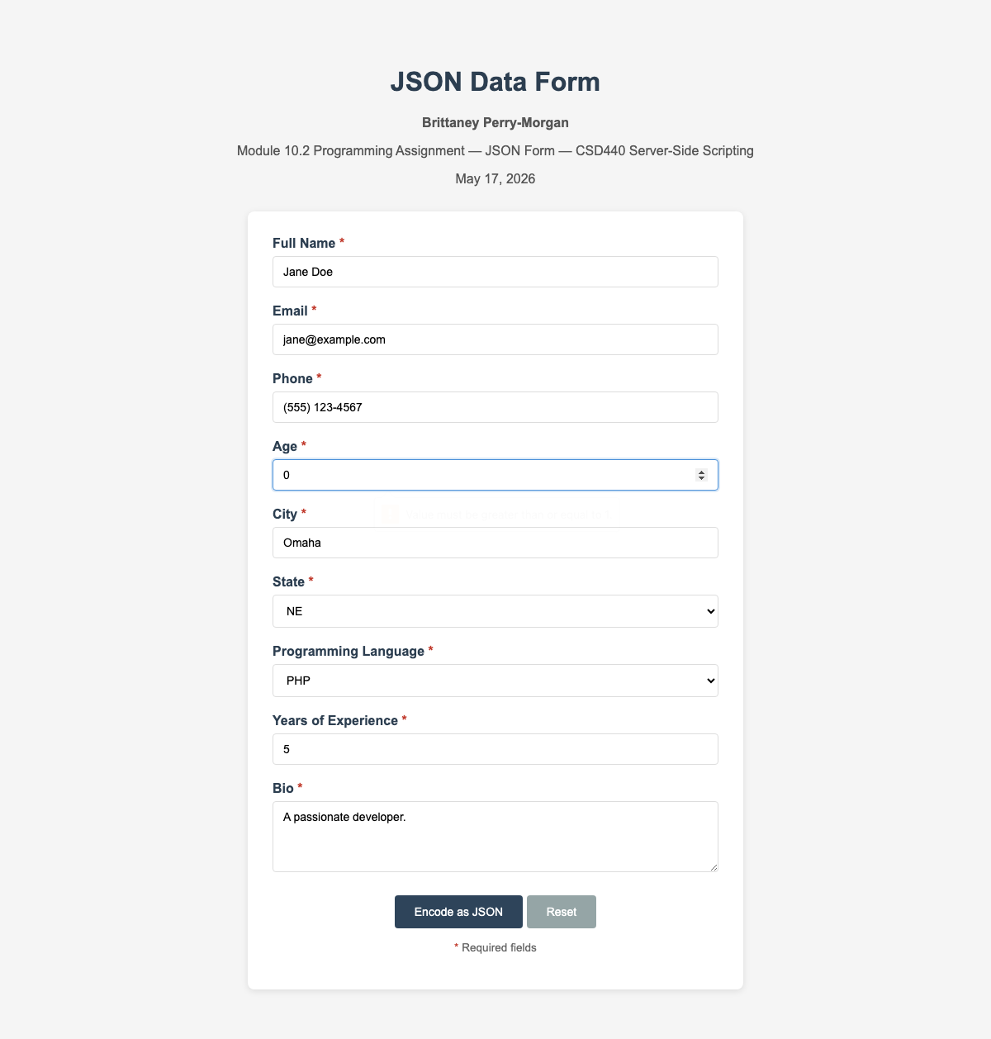

Age Above Maximum (121) — 'Age is required and must be between 1 and 120' with value preserved
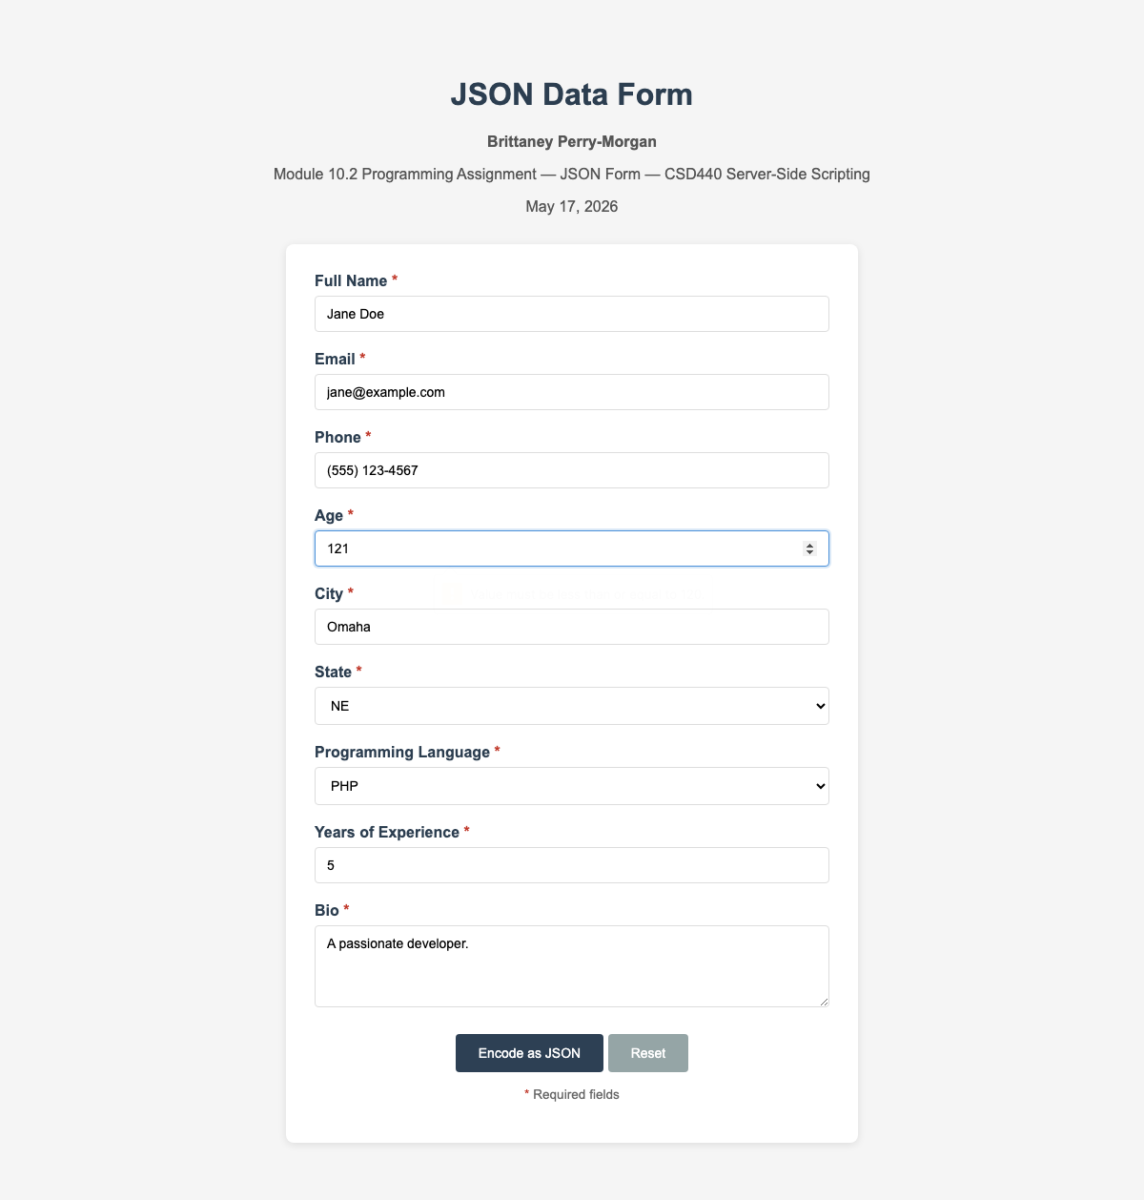

Age Non-Numeric ('twenty-five') — 'Age is required and must be between 1 and 120' with value preserved
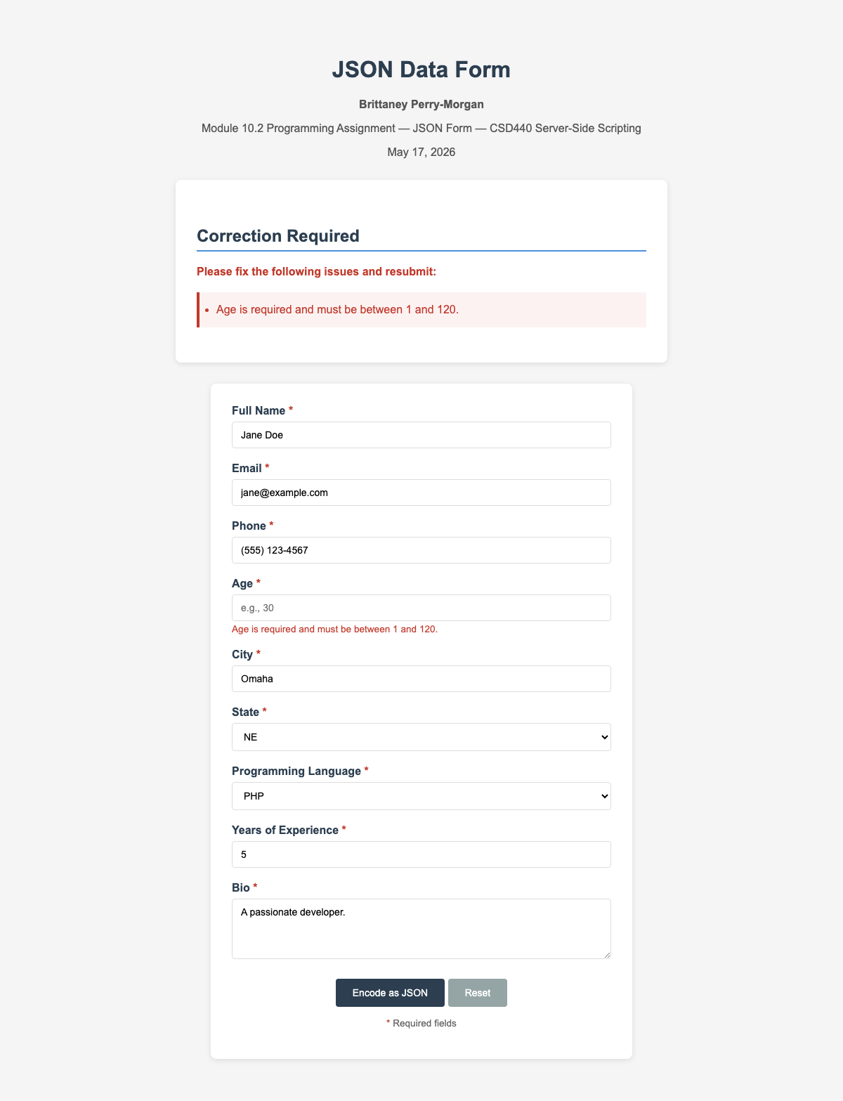

City > 100 Characters — 'City must be 100 characters or fewer' with value preserved
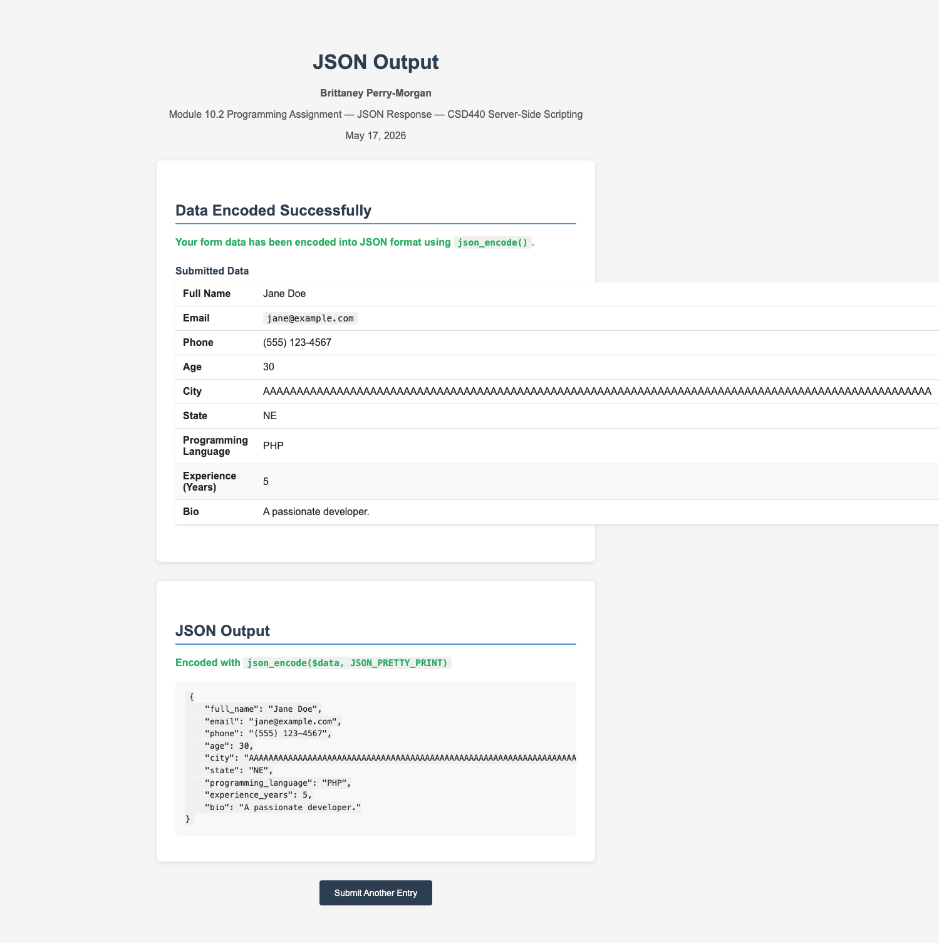

State Not Selected — 'Please select a valid state' with all other fields preserved
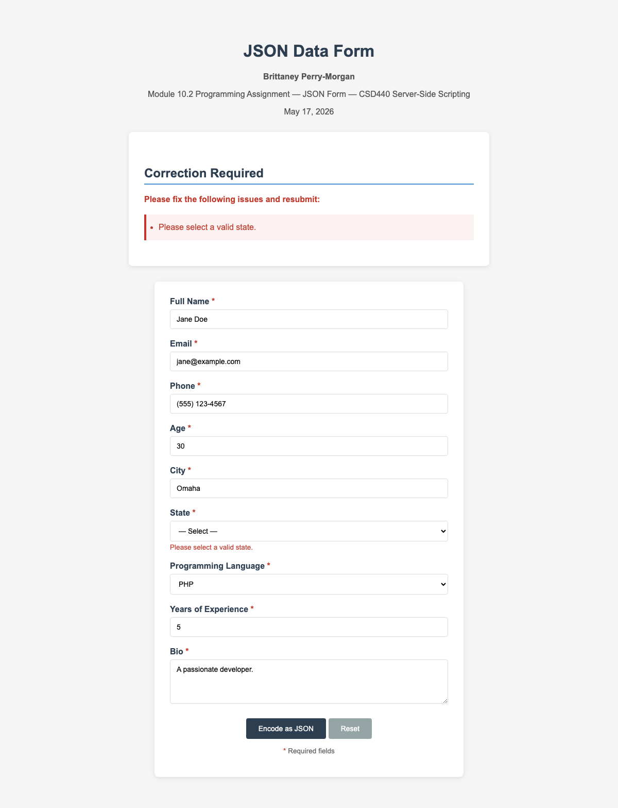

Programming Language Not Selected — 'Please select a valid programming language' with all other fields preserved
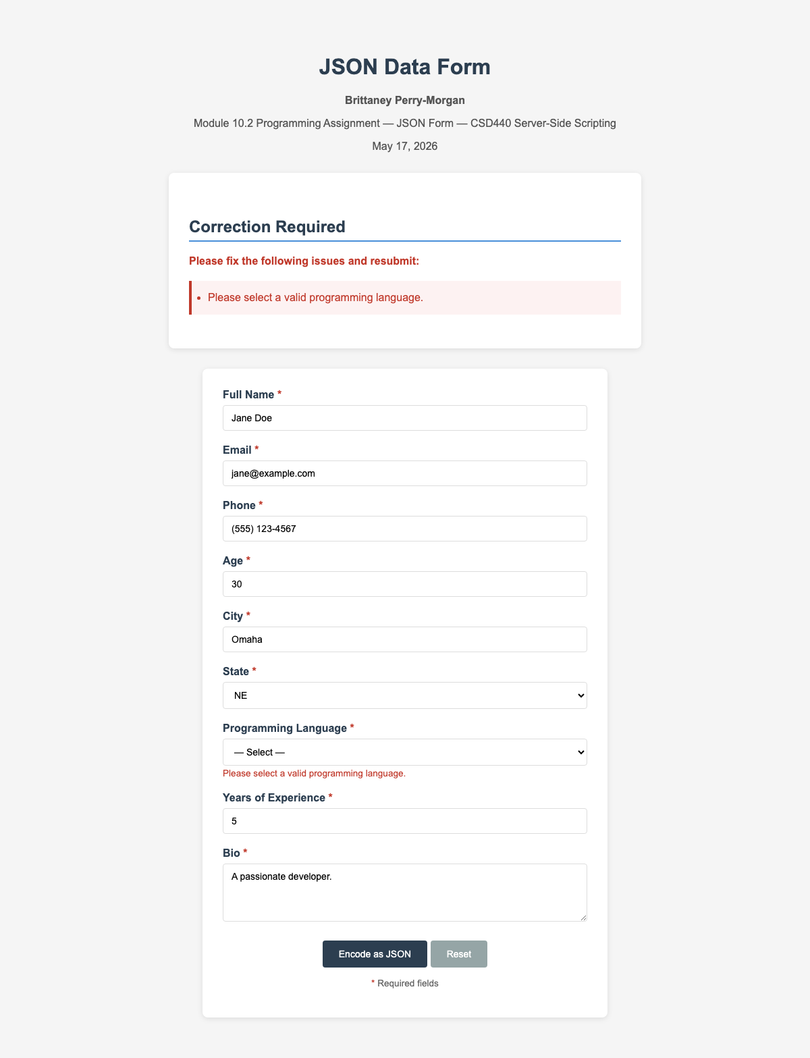

Experience Below Minimum (-1) — 'Years of experience is required (0–80)' with value preserved
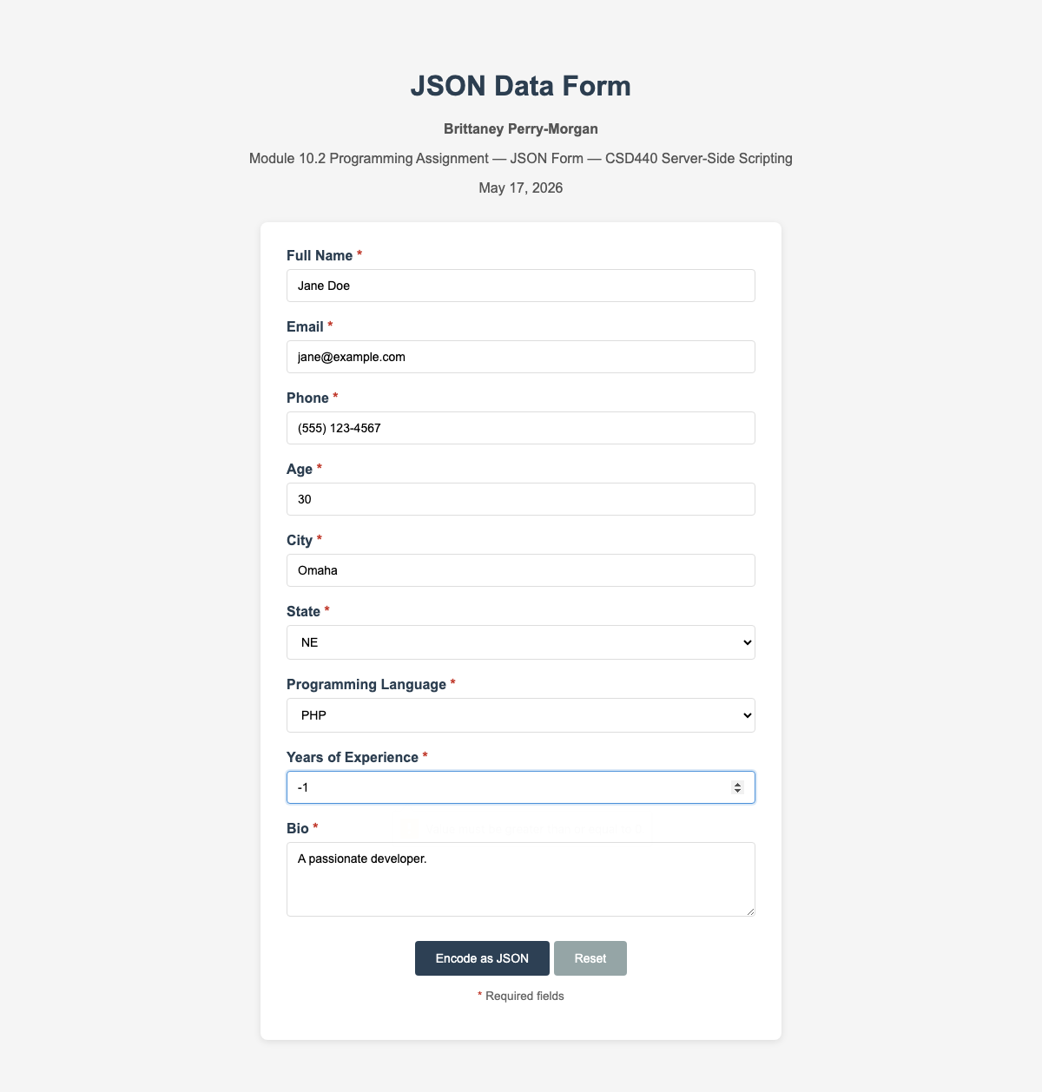

Experience Above Maximum (81) — 'Years of experience is required (0–80)' with value preserved
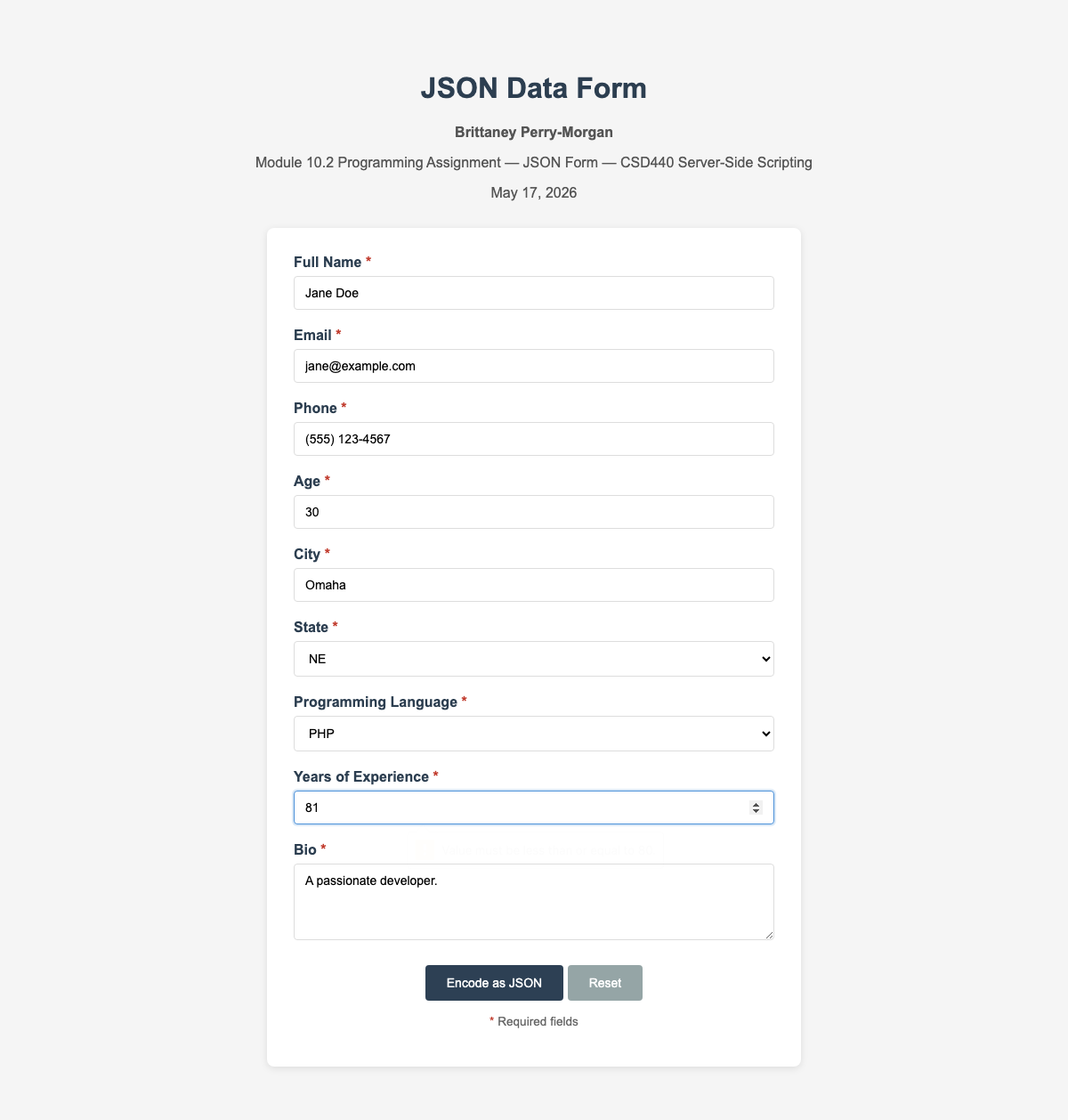

Bio > 500 Characters — 'Bio is required (max 500 characters)' with value preserved
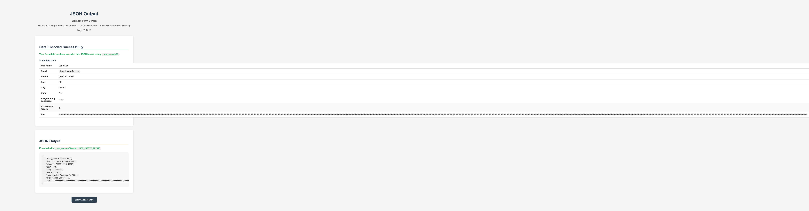

Valid Minimum Boundaries — age=1, experience=0, name='A', all fields accepted; JSON shows proper integer types
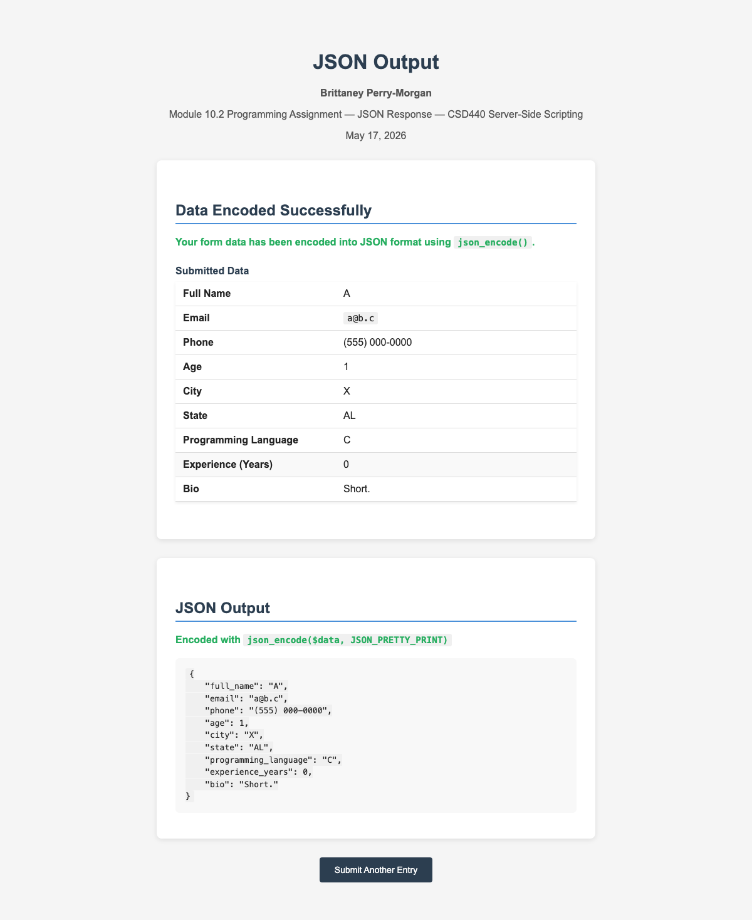

Valid Maximum Boundaries — age=120, experience=80, name/city/bio at max length; JSON accepted
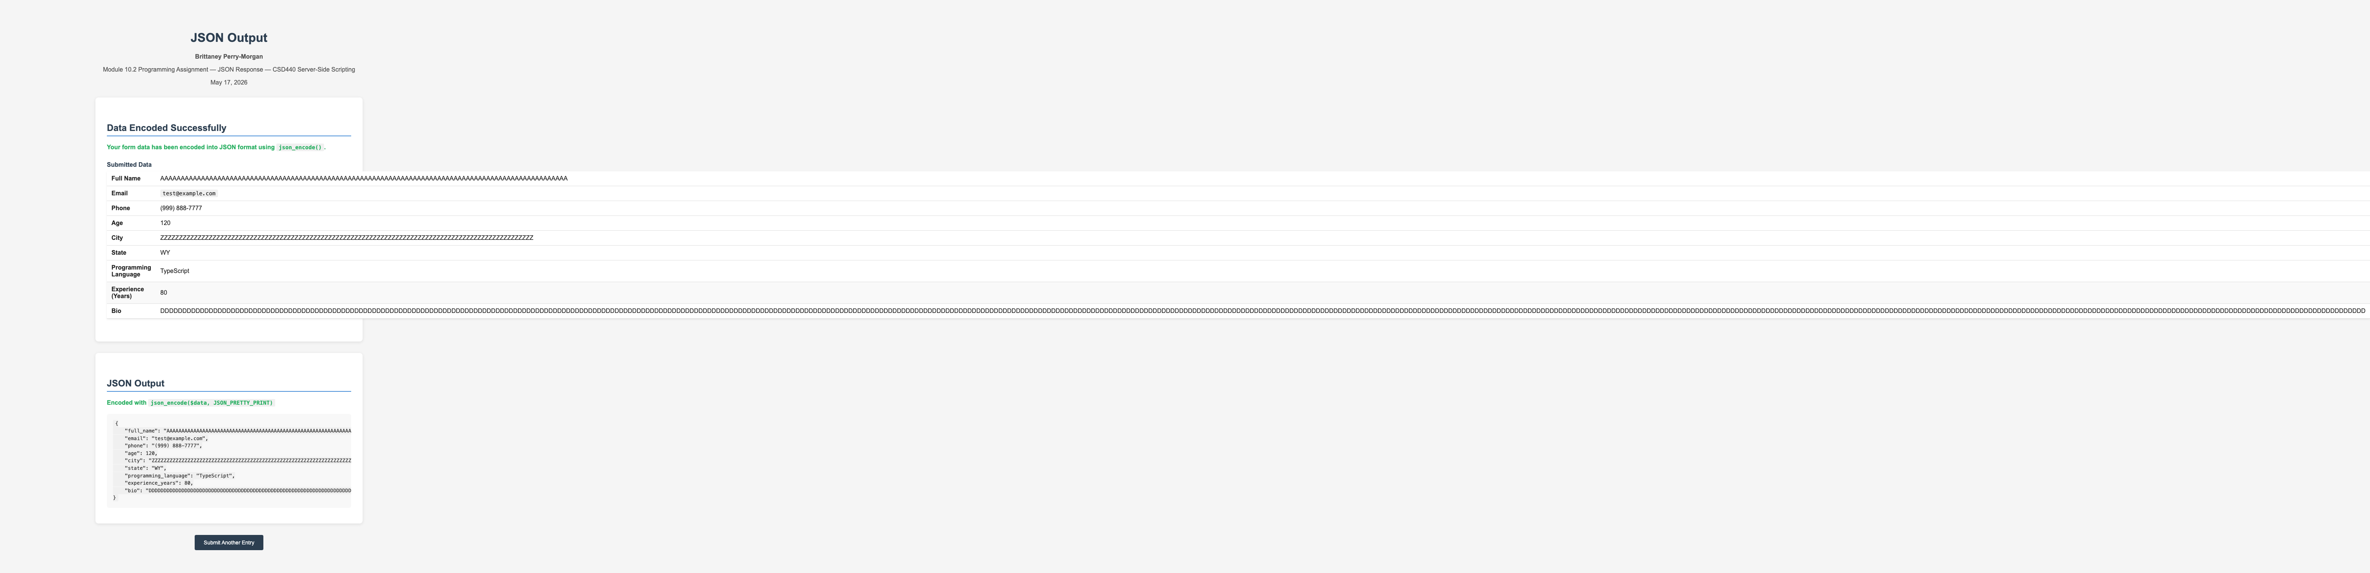

Valid Normal Submission — Typical values accepted, confirmation table and JSON_PRETTY_PRINT output displayed
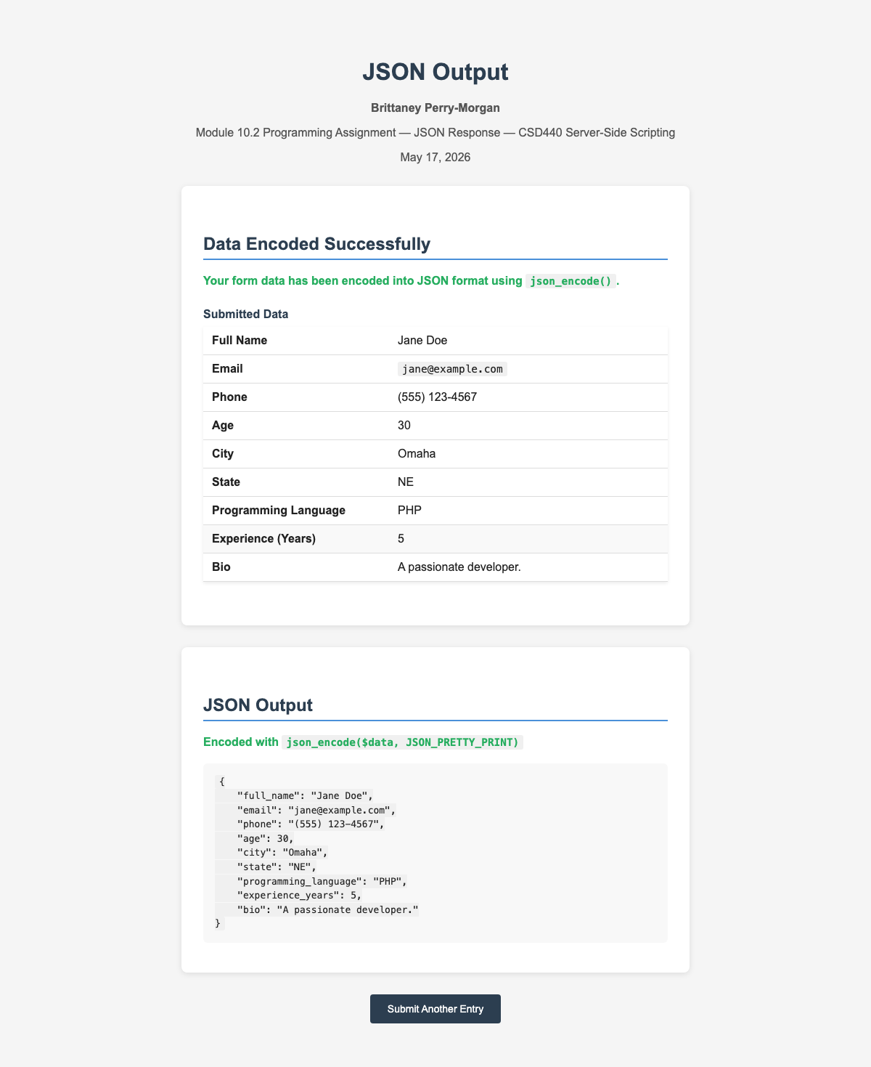

Direct Access Redirect — Accessing response handler without POST redirects to form page
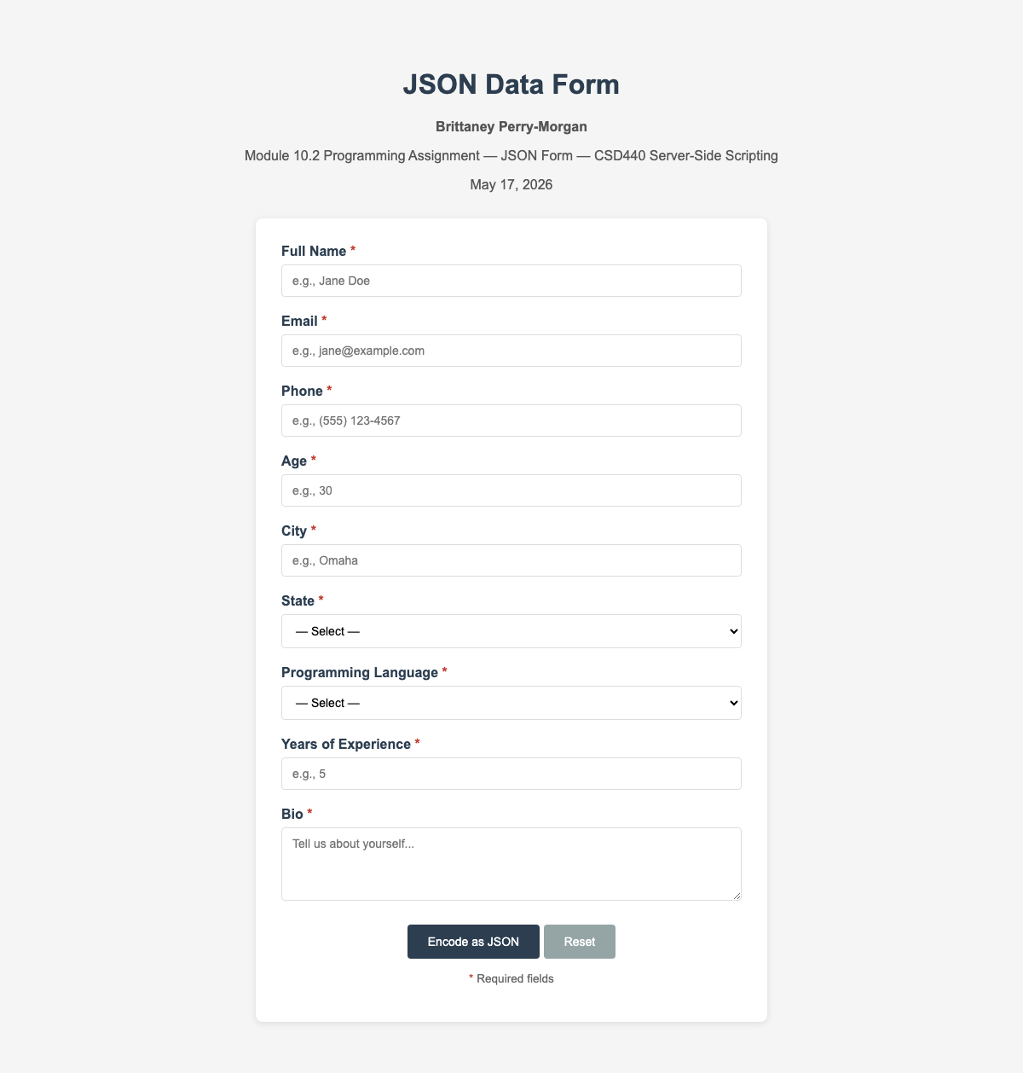

CSRF Token Tampered — 'Invalid form submission. Please try again.' with form reset
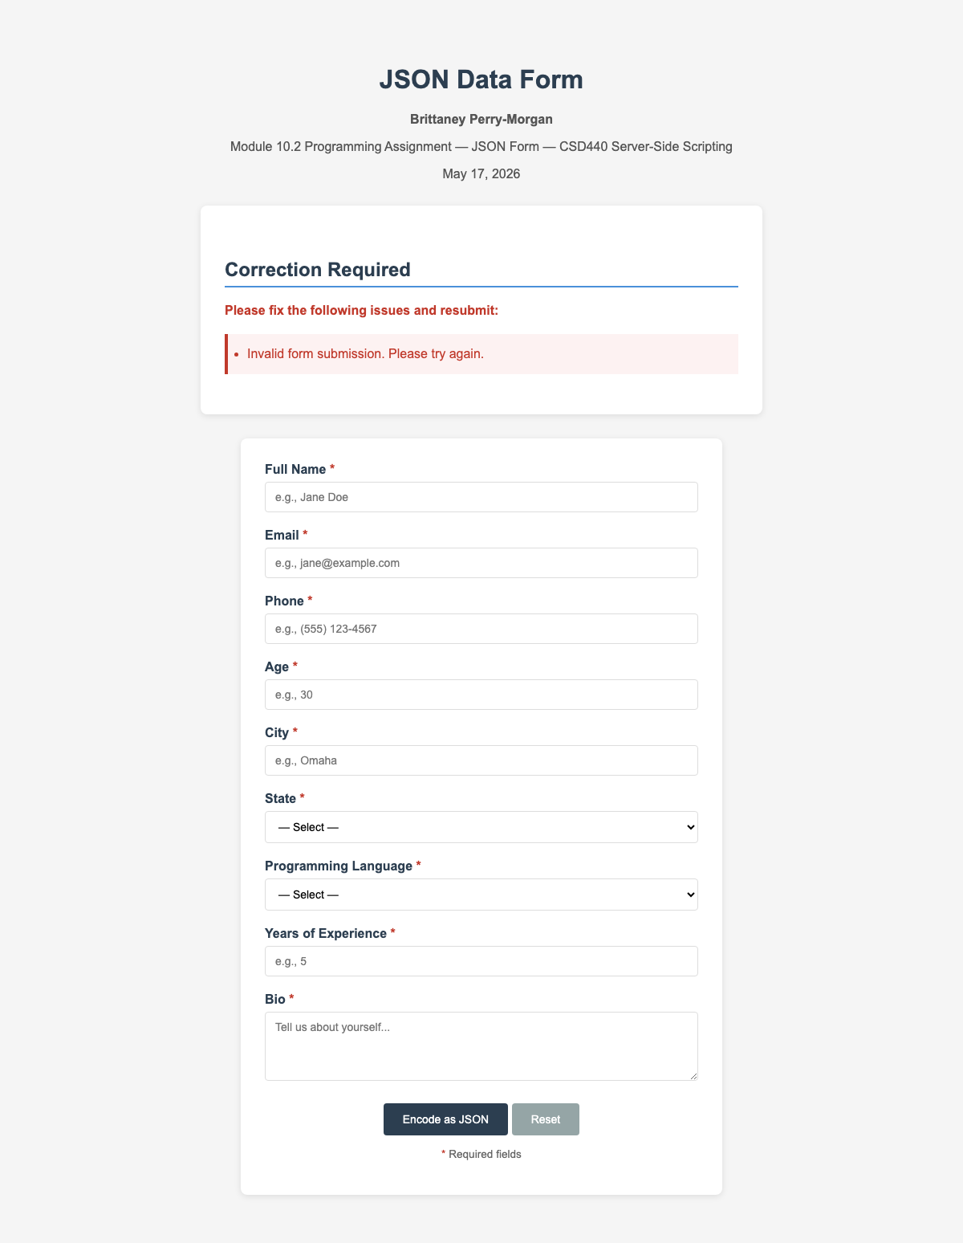

Multiple Simultaneous Errors — All validators fire together: name too long, bad email, short phone, out-of-range age/city/exp, bio too long
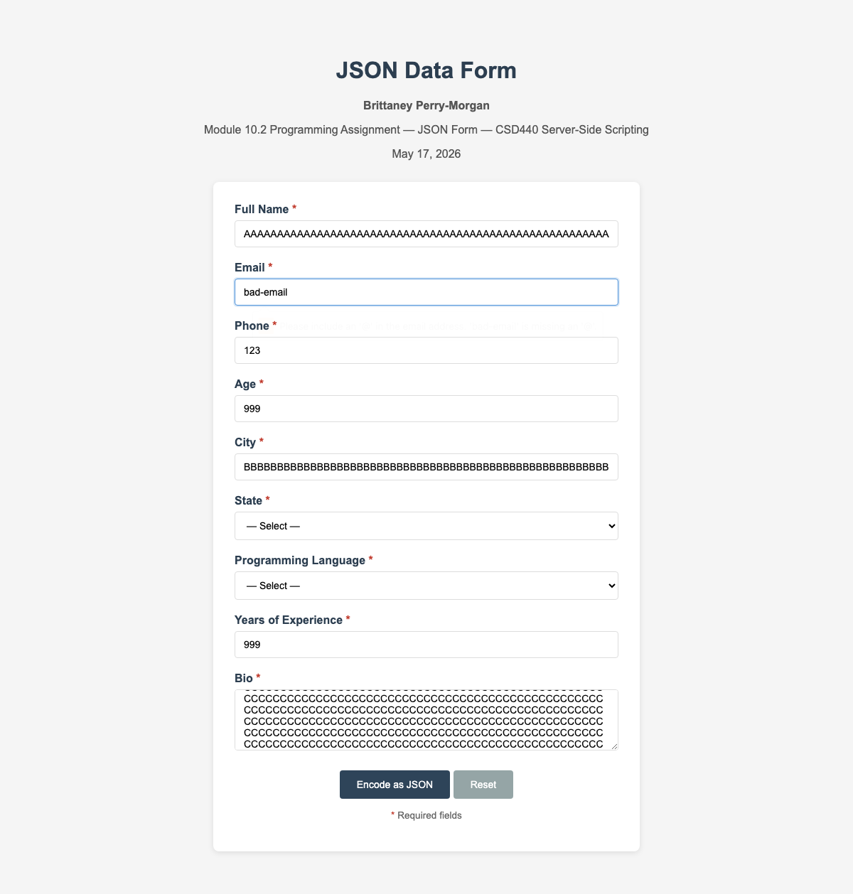

Form Repopulation — Eight valid fields preserved after redirect; only empty City field shows an error
